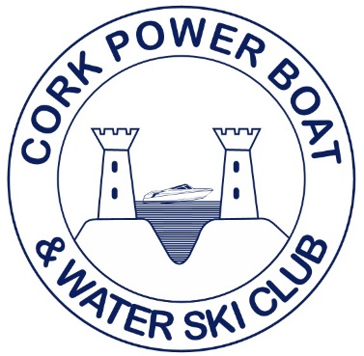
Irish National Waterski Championships 2022
Overall Results

Open Men
Daniel Galvin 1st Open Men

+45 Men
Barry Galvin 1st +45 Men

