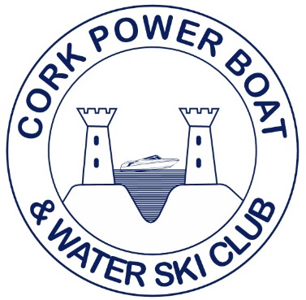
Irish National Waterski Championships 2022
Jump Results

Open Men
Jake Bridges 1st Open Men 41.3m
Daniel Galvin 2nd Open Men 35.5m

+45 Men
Barry Galvin 1st +45 Men 36m

