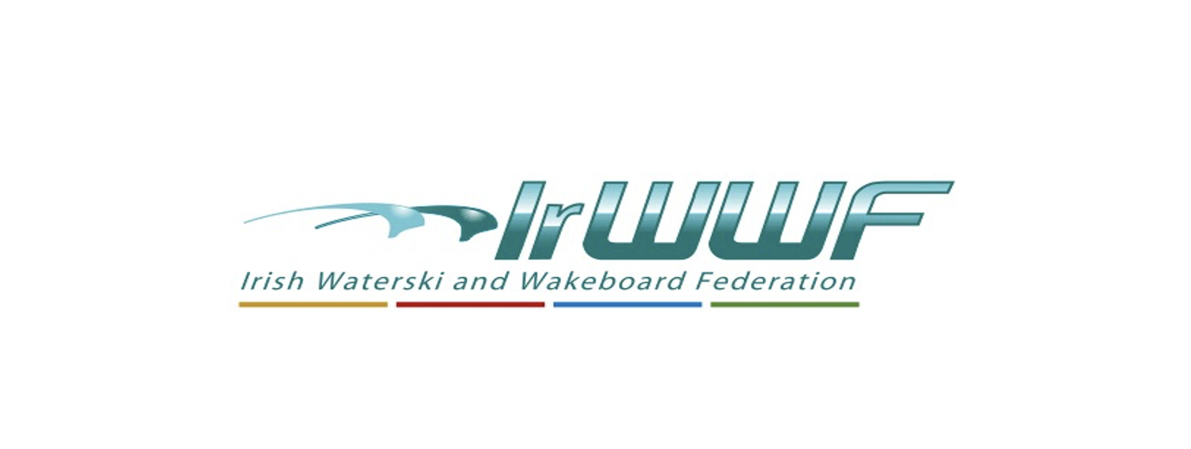
Irish Waterski and Wakeboard Federation AGM – 25th March 2023
Secretary’s Report

The AGM meeting will be held in the Clayton Dublin Airport Hotel (Stockhole Lane, Clonshagh, Swords, Co. Dublin, K67 X3H5), Saturday, 25th March 2023 at 2pm. Prior to the meeting all the invited clubs and attendees were sent the AGM Agenda, last year’s AGM minutes and the proposed amendments to the existing constitution.

The Management Committee members for the year 2022 were as follows:
- President: Paul Carroll
- Secretary: Miriam Quinn
- Treasurer: Dave Foley/Brid Deegan
- Waterski Officer: Simon Durham
- Wakeboard Officer: Dave Zebedee
- Women in Sport Officer: Keela O’Malley
The Non-Committee positions for the year 2022 were as follows:
- Child Welfare: Dianne Kirby
- Health and Safety Officer: Paul Carroll
- Equality Officer: Dianne Kirby
- Anti-doping Officer: Wilbur McDonald and Paul Carroll
- Disability Inclusion Officer: Cormac Collins
- Barefoot Officer: Andy McDonald
- Archivist: Stuart England
- Governance: Cathal O’Caoimh
- IT Officer: Cornelia Krausz
- Data Protection Officer: Cathal O’Caoimh
- Coaching Officer: Andy McQuiggan
- Technical Liaison Officer: Andy McQuiggan
Sub-Committees for the year 2022 were as follows:
- Women in Sport: Chair: Keela O’Malley
- IT: Cornelia Krausz, Miriam Quinn and Keela O’Malley
The Board of Directors for the year 2022 were as follows:
- Chairman of the Board: David Zebedee (Yr. 5)
- Company Secretary: Cathal O'Caoimh
- David O'Caoimh (Yr. 3)
- Dianne Kirby (Yr. 2)
- Miriam Quinn (Yr. 2)
- Jackie Bates Gaston (Yr. 1)

2022 for most was a year when we started to get back to some form of normal working with the removal of the Covid related restrictions however administratively this year was very challenging:
- Since the AGM the new 2022 Committee took time to find its feet. Some on the Committee found it difficult to adapt to new management, all be it with existing systems unchanged. Following on from the first Committee meeting in May the Waterski Officer, Barry Galvin, resigned his place on the Committee.
- The Committee worked away but communication soon became a problem and small issues became big ones and simple decisions became complicated. The decision making process that had been in place was not being followed and some confusion existed. This unfortunately led to conflicts and in June, Eileen Galvin asked the Board for assistance.
- There was a Committee meeting on the 22nd June 2022 and Paul Carroll attended on behalf of the Board to see if there were solutions to the issues that were clearly affecting the daily business of the Committee. At the meeting he was co-opted back onto the Committee (Note: he since resigned his position as a Director) and Cornelia Krausz then resigned and Paul was then voted in by the committee as President again.
- It cannot be underestimated how problematical the circumstances were for Cornelia and I really appreciated the way that she handled this situation, it was extremely difficult for her in the short time that she was on the committee she was professional, patient and tried really hard to build positive relationships and a more productive work environment especially as this was not of her making. She continued after these events to greatly assist us with all IT matters and provided very valuable contributions for which she deserves to be commended.
- New procedures for the appointment of any future IrWWF president and committee members have been drawn up. A special meeting was held in November 2022 to address many of the problems that arose in the year and reforms have been drafted and are being actively progressed.

- The Management committee met 11 times (versus 6 meetings in 2021) virtually on five occasions and six in person in 2022. Many of the times committee decisions also had to be made by way of email/instant messaging/teams app. Administratively it was hugely demanding and the graphs below show the vast increase in the workload since I have commenced this role.

- In brief:
- 10 club affiliation fees have been lodged and grants have been paid to them.
- The Management Committee have decided to move forward and use “Microsoft Teams” as our central communication platform. It is still in the trial-and-error stage, but the benefits are wide-ranging and will allow for smoother transitions going forward.
- Committee members have received Teams training and IT back up is available thanks to Cornelia Krausz.
- We are also now trialling “Spond” as opposed to Whats App or other messaging platforms. It appears safer, more GDPR compliant and secure.
- The Management Committee has formalised an application process which sets clear criteria and lets Clubs know well in advance what is required if the Management Committee are to release funding. The process will be online and each application will need to meet the criteria before funds are released. This will help with both administration and transparency.
- Agreed a “Minimum Safety Requirement” Document which outlines the responsibilities of the hosting Club safety wise, so, again, as there is no ambiguity as to what is expected.

- In summary, the committee’s main topics/objectives were as follows:
- Sport Ireland increased the core grant allocation from €40,000 in 2022 to €42,000 in 2023 with an additional covid grant of €25,000.
- 5 round Slalom League competitions completed. The committee wish to acknowledge with thanks, Eamonn Prunty for hosting the final event with an awards presentation and Carl Cautley who undertook the scoring for the league.
- Total IrWWF licences and income has increased since last year.
- A resoundingly successfully Wakeboard Nationals was held in June
- We had 11 athletes attend 6 International events: with 9 Podiums. Athlete’s reports published on social media.
- Waterski Nationals were held in July.
- Level 1 coaching course delivered.
- Watersports Inclusion Games supported and attended.
- Vision Sports Ireland Day supported.
- Disability week event supported.
- 2023 Coaching plan prepared with Andy McQuiggan submitted and approved by Sports Ireland Coaching
- 2022 Anti-Doping report and 2023 Anti-Doping Educational plan submitted to Sports Ireland.
- Significant governance issues & induction training completed by Board Secretary, Cathal O’Caoimh https://www.irishwwf.ie/iwwf/governance/policies-dash-general-irwwf
- Cornelia Krausz set up a federation Instagram account which is also linked to our Facebook account.
- Clubs were informed that the Spine Boards and Defibrillators issued in 2015 are no longer the property of the federation and are now the sole responsibility of the clubs.
- 9 affiliated clubs were paid a one-off insurance assistance grant of €700 (each) at the end of 2022.
- Ireland on the water Expo 2023: Maramedia hosted an EXPO of all things water related 3rd - 4th March at the EIKON Centre, Lisburn. The IrWWF took a small stand and promoted the Federation and our Affiliated Clubs.

These matters will be dealt with in more detail in the reports of the committee officers with responsibility for same.

I wish to conclude my report by thanking my fellow officers for their help and support over the year. I would also like to wish the incoming committee well in the year ahead

Miriam Quinn
IrWWF Committee Secretary

