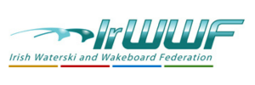
Disability Officer`s report to AGM 2024
There were 2 events held in 2023 that involved the federation assisting people with disabilities access our sport.
- Watersports Inclusion Games.

Wexford Harbour sailing & tennis club
23,24 & 25th June.
Friday 23rd: site set up & River Slaney familiarisation followed by Briefings by event organisers Sail Ireland.
Saturday 24th: 2 sessions, morning & afternoon at which we assisted 14 people to ski.
Sunday 25th: 2 sessions, morning & afternoon when we assisted 12 people to ski.

Irish Waterski & Wakeboard Federation Team for weekend,
Andy Mc Quiggan, Paul Carroll, Brid Deegan, Aisling Deegan & Cormac Collins.

Local Wexford Team.
Kieran, Thomas & Killian Mc Guinness, along with a fully maned safety boat from WHS&TC with us for the weekend

We got an opportunity on Saturday to showcase our sport & how we assist people with disabilities to the CEO of Irish Sport, Dr Una May. She joined us on the boat along with a camera crew for a half hour demonstration.

It was a very successful week-end for Irwwf , showing how our sport is accessible to all, and helped in no small way by the Mc Guinness family who openly welcomed us & all the participants onto their river access & provided their boat, a Super Air Nautique, fuel, jetty, staging area, changing room, tea&coffee & their time willingly. Generous people like them make events like WSIGs so much easier & enjoyable to run.
Paul Carroll wrote a report in July last & posted it on the website which is worth a read.

On behalf of the Federation, I would like to say a big thank you to all the people who helped with their time, along with those that provided us with the gear including Carrig Wake & the federation.

The 2024 WSIGs are being held 22nd & 23rd June in Ramor Watersports Club, Virginia, Co Cavan & Irwwf have again been invited to participate. If anybody wishes to be involved or provide us with a ski boat, we would be delighted.

- Spinal Injuries Ireland 1 Day Event in Wake N Ski

Hosted by David O Caoimh & Eamonn Prunty . I`ll leave it to David to explain all about the event.

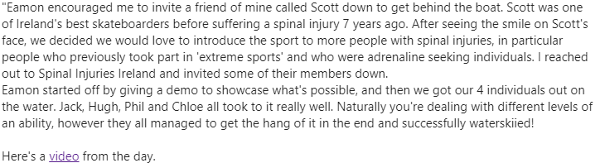
This was a wonderful event and I hope that our partnership with people with Spinal Injuries can continue into 2024.

Cormac Collins
Disability Inclusion Officer

